

11 Physics

Electricity
ELECTROSTATICS

If two objects of different materials are rubbed together, such as a plastic ruler and a woollen jumper, static electricity results. The friction between the objects causes a transfer of electrons from one of the materials to the other. This results in the bodies acquiring equal and opposite static charges.

Electrostatics is the study of the causes and effects of these static charges. Some common
occurrences that can be explained by electrostatics are listed.

• You can sometimes get a small electrical shock after walking across new carpet.
• A plastic comb run through your hair will attract small pieces of paper.
• A balloon that is rubbed against some clothing will tend to stick to walls.
• You can sometimes feel a small electrical shock from a car after travelling for some
time.

Electrostatic experiments with many different materials have established the following.

• Only two types of charges exist, positive and negative. Positively charged objects have
a deficiency of electrons. Negatively charged objects have an excess of electrons.
• Like charges repel, unlike charges attract (called the Charge Law).
• Both positively and negatively charged objects attract neutral conductors.

The build up of charge on an object is called static electricity.

Examples

1. Consider the build up of charge when walking on certain carpets.

2. Formation of Lightning

If the charge build up on two objects is great enough, and these charges are opposite in sign,
then a spark may jump between the two.

It is this effect that is responsible for lightning discharging between clouds and the Earth.

Strong updrafts within the clouds drive ice crystals and hailstones into collisions, forming a
separation of charge.

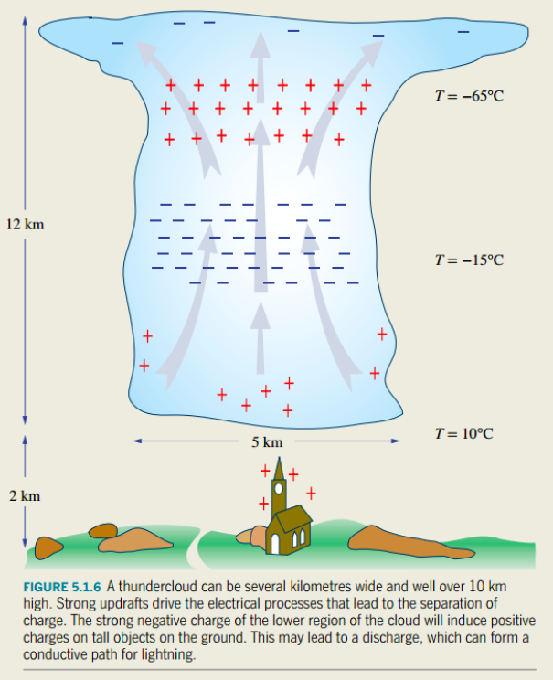

3. Electrostatic Induction
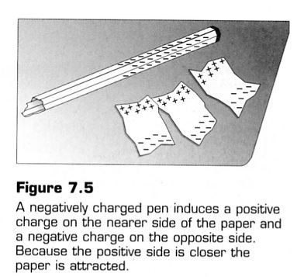
When a pen is rubbed on a woollen jumper, it becomes negatively charged. It creates around itself an electric field in which negative charges will move away from the pen and positive ones towards it.

Any electrons in the paper that are free to move will therefore move to the opposite edge of the paper, leaving the edge closest to the pen with an excess of protons and thus a positive charge.

While the paper is still neutral overall, this positive charge is closer to the pen than is the negative charge on the other edge, and will therefore be attracted more strongly than the negative
charge is repelled.

Fundamental Charge

The elementary charge (e) is given as that charge on a proton or electron.

i.e. e = 1.60 x 10⁻¹⁹ C (where C represents the units Coulombs)

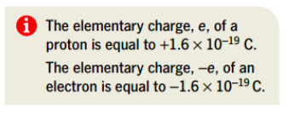

Examples

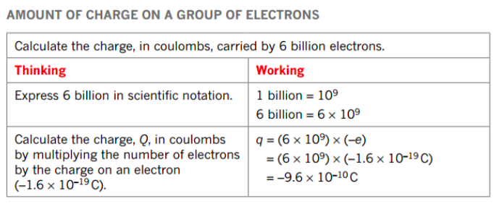

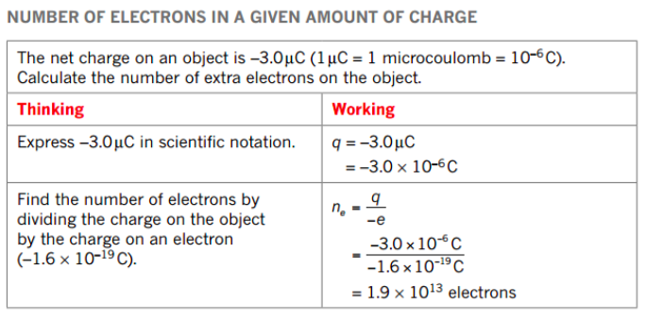

ELECTRIC FIELDS

A charged object has an electric field associated with it, and this influences other charged objects placed in it.

The electric field strength is defined as the force per unit charge.

i.e. ** No calculations are required.

where E = the electric field intensity (NC⁻¹)
F = the force exerted on the charged object in the
electric field (N)
q = the size of the charge on the object in the
electric field (C)

Electric field has both size (strength) and direction, hence it is a vector.

The direction of an electric field is taken as the direction a positive test charge, when placed in the field, would move.

i.e. Away from a positively charged object.

The electric field is represented by lines of force or flux.

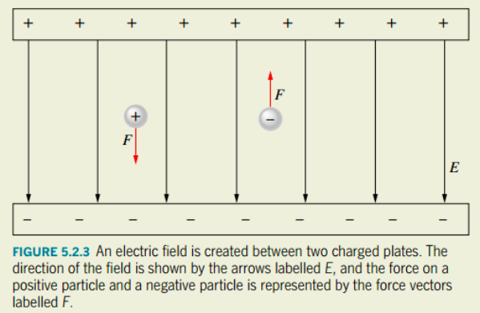

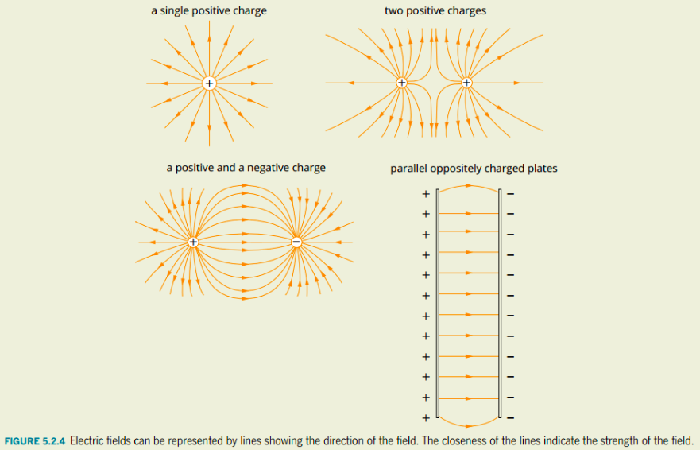

ELECTRIC POTENTIAL

The Earth is defined as having zero potential.

Charged bodies gain electrical potential energy when they are moved in an electric field.

Consider a positively charged body that cannot move and is insulated from the Earth.

If a positive charge is brought to point B,
work has to be done to overcome the
repulsion.

This work is stored as electric potential
energy.

If it is moved to point A, it has a higher
electrical potential energy.

Points A and B have different potentials -
there is a potential difference.

ELECTRICAL POTENTIAL DIFFERENCE

Moving a charge in an electric field involves work (energy) and hence a change in electrical potential energy.

A potential difference of 1.00 V exists between two points if a charge of 1.00 C moving
between those points has its electrical potential energy changed by 1.00 J.

Potential difference is therefore defined as the work done per unit charge in moving the charge through an electric field.

i.e.

where V = the difference in potential between two points in an electric field (V - volts)
W = work done in moving the charge (J)
q = the amount of charge moved in the electric field (C)

Note

The voltage, correctly termed EMF (electromotive force - ε) of an electrical source such as a battery, is a measure of the energy supplied to each coulomb of charge passing through it. Hence a source such as a battery supplies electrical potential energy.

When a charge is placed in an electric field, it experiences a force and moves. It moves from one potential to another, thus requiring some work to be done.

If work is done in moving the charge, it must change E_{k}.

i.e. W = ΔE_{k}
=> Vq = ¹/₂ mv² - ¹/₂mu²

Since the charge starts from rest, ¹/₂ mu² = 0.

∴ W = Vq = ¹/₂mv²

This Physics principle of accelerating charges is best considered in the electron gun inside an old-style TV .

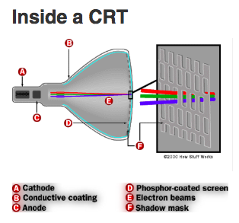
Example

The electrons inside the "red" electron gun of a old-style colour TV (using a cathode ray tube) are accelerated by a potential difference of 1.32 x 10³ V. Determine how fast these electrons leave the gun to move down the picture tube.

(Data - mass of electron = 9.11 x 10⁻³¹kg, charge on electron = 1.60 x 10⁻¹⁹ C)

ELECTRIC CURRENT

Any material that contains electric charges that are free to move is called a conductor. If such a
material is connected between points of different electrical potential, then a flow of charge will
occur.

The rate of flow of electric charges, whether positive (+) or negative (-) is called an electric current. In a conducting solution both positive and negative ions are charge carriers while in a metallic conductor only electrons are charge carriers.

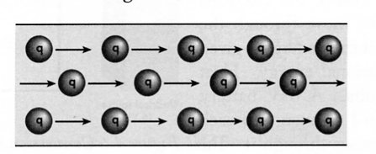

• Conventional current is defined as being in the direction of positive charge flow. It
may be considered as a current opposite in direction to a flow of electrons. When we
refer to the direction of current in a circuit we are referring to conventional current.

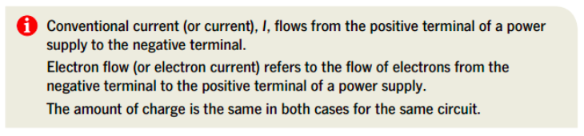

• Direct current (DC) refers to a current supply where the flow of charge is always in
one direction (eg. current from a battery).

• Alternating current (AC) refers to a current supply where the flow of charge alternates
back and forth (eg. household supply).

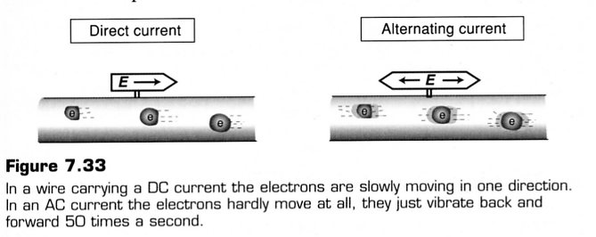

The magnitude of a current is given by:

where I = current (Amperes - A)
q = amount of charge (C)
t = time taken for the charge to flow (s).

Examples

1. Determine the charge that has flowed through a torch battery producing a current of
3.00 x 10² mA if it has been on for 20.0 minutes.

2.
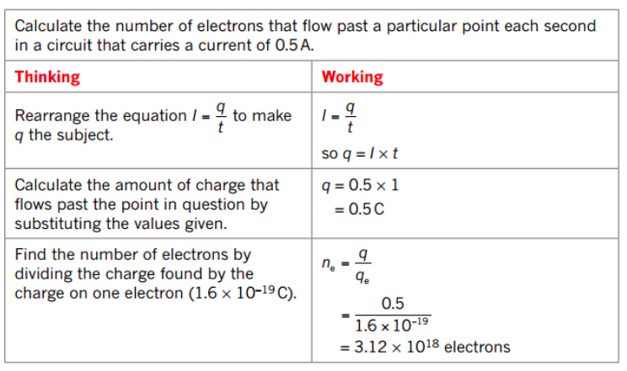

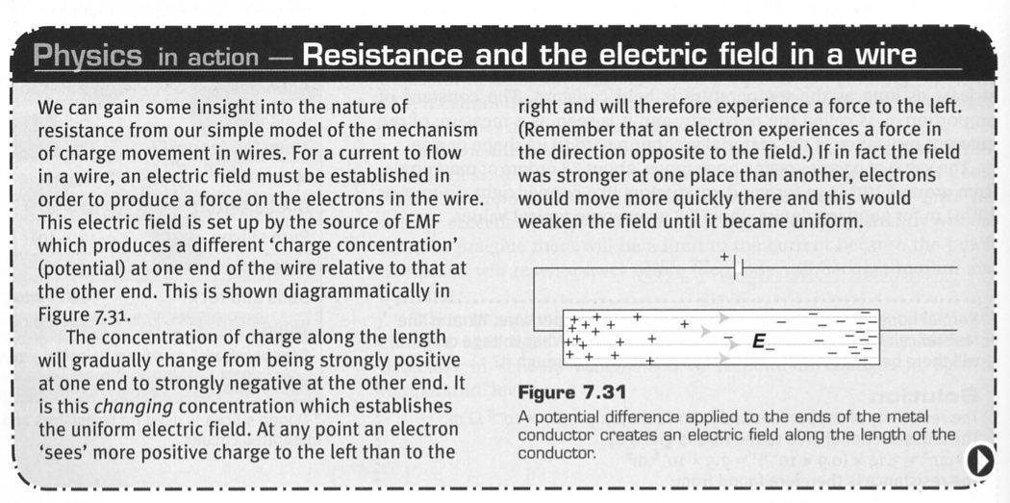
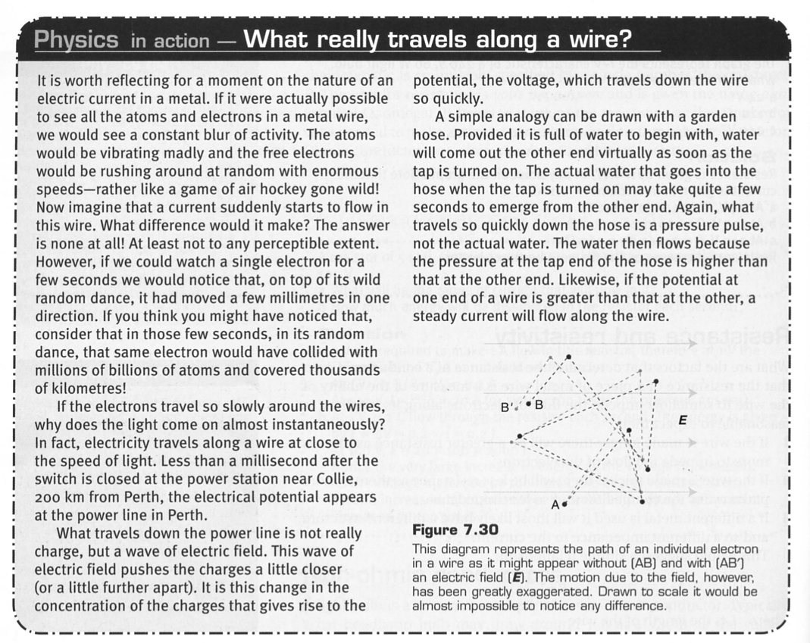

ELECTRICAL CIRCUITS

Electrical circuits allow the flow of charge from an electrical energy source to components connected within the circuit by conducting material. These circuits maybe very simple or complex.

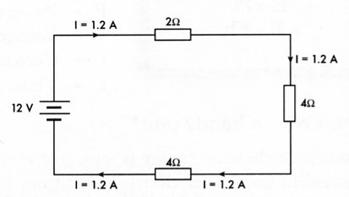
There are three recognisable types of circuits.

• Series Circuits

There is only one possible path for the current and the
same current flows through all parts of the
circuit.

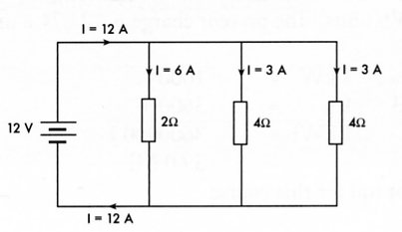

• Parallel Circuits

The current has more than one possible path.
The sum of the currents in the different parts of
a parallel circuit is equal to the total current .

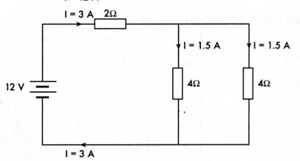

• Complex Circuits (Networks)

These are a combination of series and parallel
connections. Most electrical devices involve
complex circuits.

CIRCUIT DIAGRAMS

Electrical circuits are best represented by diagrams which show each component of the circuit as a
symbol. Conventional symbols used to represent components are shown below.
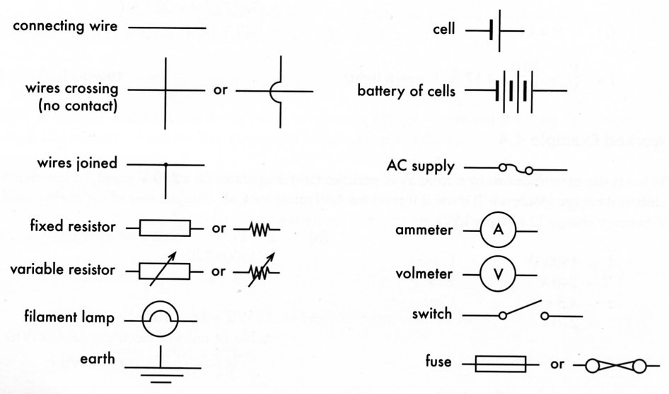

RESISTANCE

The electrical resistance of materials varies widely, from zero for superconductors to extremely high values for insulators. The availability and number of `free' electrons within a material greatly affects the ease with which a current will flow through it.

The resistivities of different substances (see next page for definition) can be used to classify them as follows.
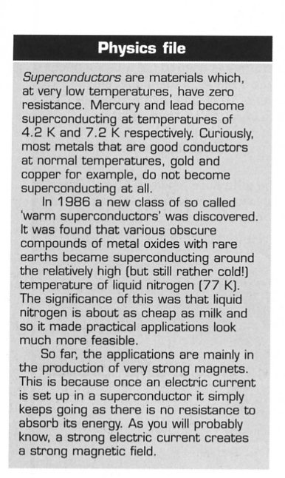
• Superconductors

Some metals and ceramics have zero resistance when they are cooled to temperatures close to
absolute zero. Applications include magnetic levitation.

• Good conductors

Most metals have low resistivities (in the order of 10⁻⁸ Ωm) and are suitable for use in electrical wiring. Metals and alloys with relatively higher resistivities (about 10⁻⁶ Ωm) are useful for resistor and
heater filaments.

• Semi-conductors

Non-metals such as germanium and silicon have relatively high resistance. However the resistance of these materials can be markedly and selectively reduced by introducing specific impurities.

This special property allows the production of transistors and microchips, which are vital components for the electronics industry.

• Insulators

Materials such as wood, glass and plastic have extremely high resistivities (10¹⁰ to 10¹⁵ Ωm) and are therefore very useful insulators. They are very necessary for the safe operation of electrical
devices and the prevention of electrocution.

POTENTIAL DIFFERENCE AND CURRENT - OHM'S LAW

The relationship between the current flowing through a resistor and the potential difference applied
to it was first investigated by the German physicist Ohm. He found that:

"provided that the temperature remains constant, the current through a resistor is
proportional to the potential difference applied across it".

This is known as Ohm's Law. This law only applies to metals and carbon at constant temperature. It is usually expressed as follows.

V = IR

where V = voltage or potential difference (V)
I = current (A)
R = resistance (Ohms - Ω)

Example
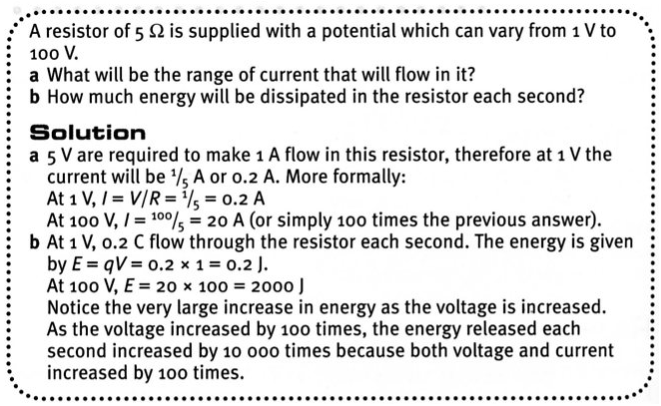

Ohmic Conductors

Ohmic conductors are those whose resistance remains constant as the current is varied. The slope
of their V/I graph would be constant. Resistors and conducting wires used in circuits are ohmic conductors within specific limits.

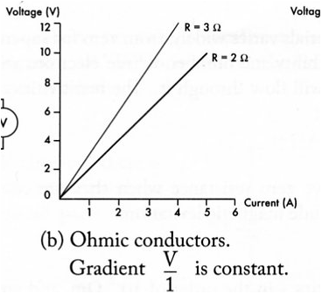
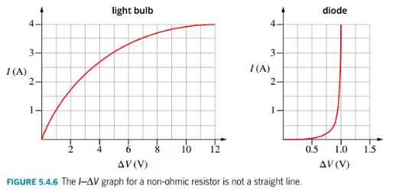
Non-Ohmic Conductors

Non-Ohmic conductors do not show a constant relationship between voltage and current. Their resistance can increase with temperature, as does a globe filament, or decrease, as is the case with thermistors.

VOLTMETERS AND AMMETERS

A voltmeter is used to measure the voltage (potential difference) between two points. It is
therefore connected in parallel to the component it is measuring the voltage across.

Voltmeters are high resistance instruments. This is so that very little current is diverted from the
circuit when a voltage measurement is made.

An ammeter is used to measure the current flowing through a particular point in a circuit. It is
therefore connected in series at that point in the circuit.

Ammeters are very low resistance instruments so that they will have little effect on the current
flowing in a circuit.

Polarities of connections. The positive terminal of an ammeter or voltmeter is always connected
to the part of the circuit coming from the positive terminal of the power supply.

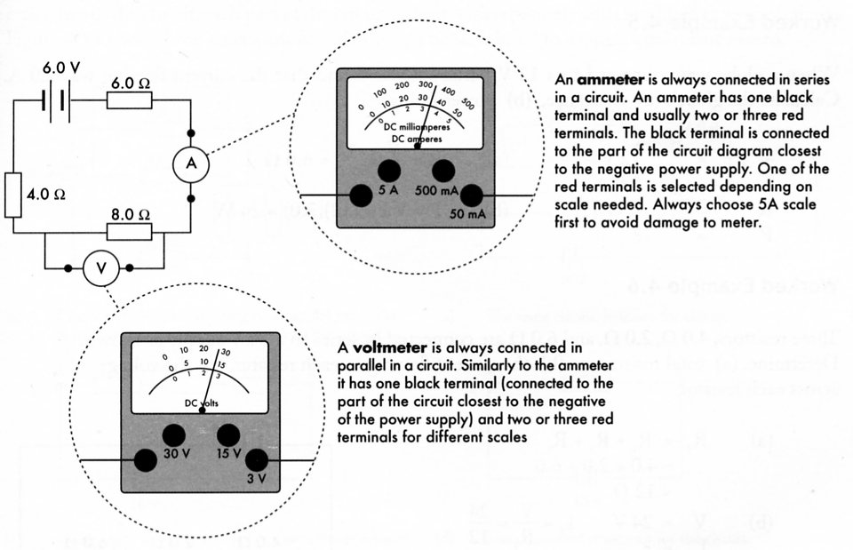

RESISTANCE AND RESISTIVITY

The electrical resistance of a conductor depends upon the type of material it is made from, as well as its size and shape. Factors that affect the resistance are:

• Length (l) - resistance increases proportionately with the length of a conductor.

i.e.

• Cross-sectional area (A) - the greater the cross-sectional area of a conductor, the
smaller its resistance.

i.e.

• Nature of the conducting material - an electrical property of materials is their
resistivity (ρ). The resistance of a conductor is proportional to its resistivity.

i.e.

• Temperature - the higher the temperature of a metal the greater its resistance. The
higher the temperature of carbon the lower its resistance.

These first three relationships can be combined as follows.

** No calculations are required.

where R = resistance (Ω)
r = resistivity (Ωm)
l = length (m)
A = cross-sectional area (m²)
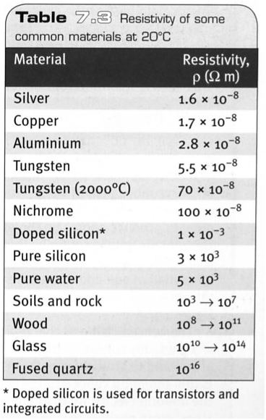
Example
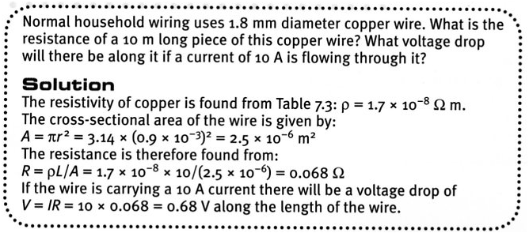

Effect of Temperature

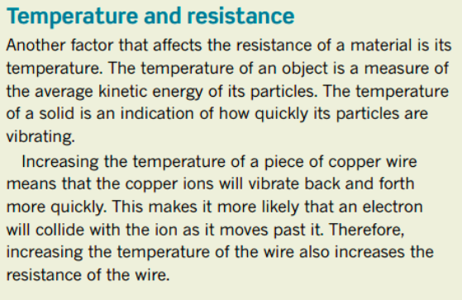

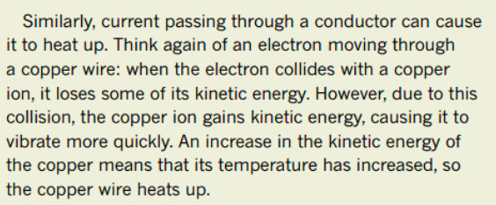

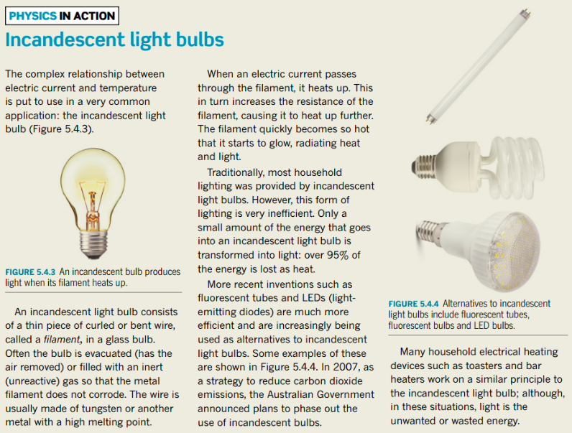
ELECTRICAL ENERGY

Sources of electricity such as batteries provide energy to the charges flowing in a circuit. A
battery contains stored chemical energy that is given to the electrons as electrical potential energy.
This is converted to kinetic energy as the electrons are attracted to the positive terminal.

Since the electrons collide with atoms as they move through the different parts of the circuit, their energy is given up to the atoms as vibrational energy. Heat and sometimes light results.

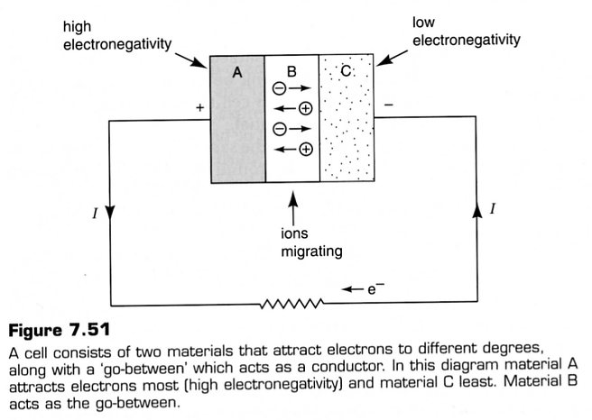

e.g. A 6.00 V battery will supply 6.00 J of energy to each coulomb of charge that passes
through it (from ). This exact energy is then lost to the external circuit by each
coulomb of charge.
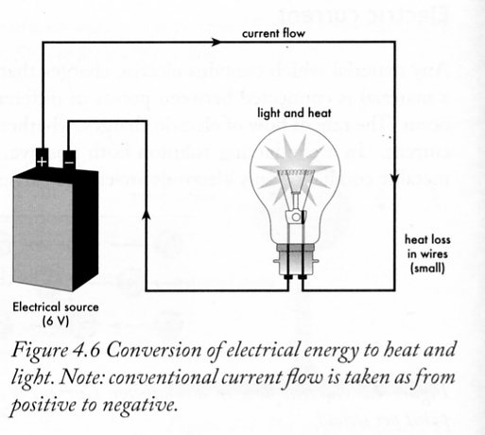
ELECTRICAL POWER

Power is defined as the rate of doing work or releasing energy.

Examples

1.
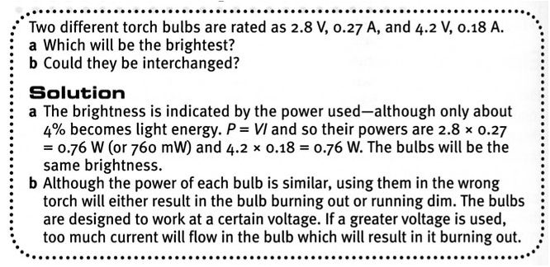

2.
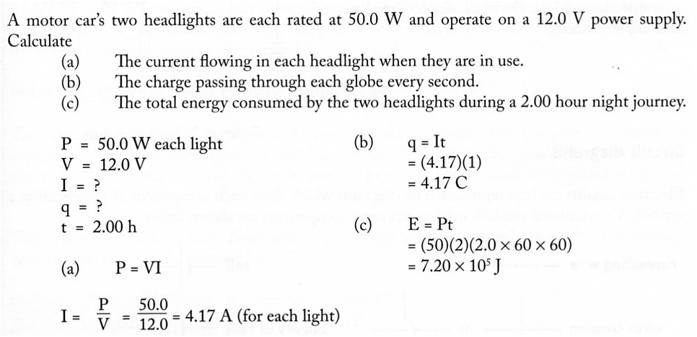

From V = IR and P =VI, the power dissipated in a component in a circuit is given by:

Electrical Energy Used

The energy consumed by an electrical appliance depends upon the rate of energy use (power rating), and the time for which it is operating.

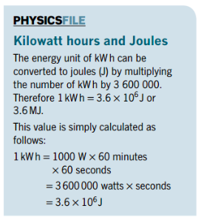
The Kwh - A Handy Unit

Household electrical energy is measured in units called "kilowatt-hours" (kWh) since it is a more convenient unit. Your electricity bill from Western Power will refer to electricity units used. These
are kWh units.

Since 1 kW = 1000 Js and 1 h = 3600 s

∴ 1 kWh = 3.60 x 10⁶ J = 3.60 MJ

Examples

1.
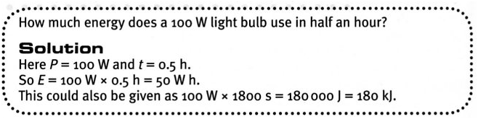

2.
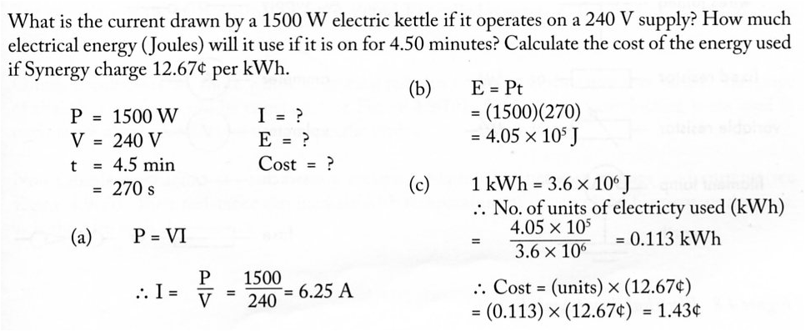

3.
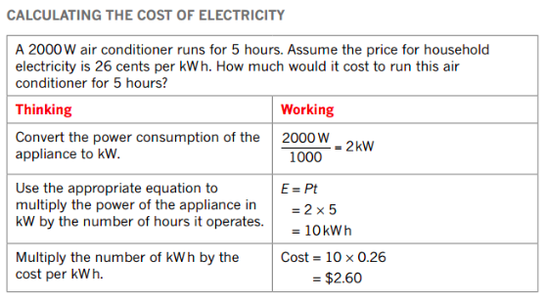

SERIES CIRCUITS
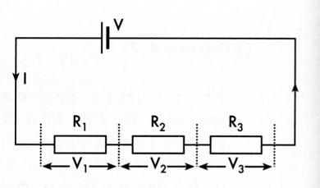
The diagram at right shows resistors that are connected in series.

• The supply voltage (V) is shared among the resistors.

ie. V_{T} = V₁ + V₂ + V₃

• The same current (I) goes through all the resistors.

• The total resistance is the sum of the individual resistances.

i.e. R_{T} = R₁ + R₂ + R₃

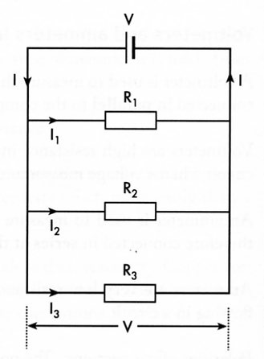
Parallel Circuits

The diagram at right shows resistors that are connected in parallel.

• The current is shared among the resistors.

i.e. I_{T} = I₁ + I₂ + I₃

• The same voltage (V) exists across each resistance.

• The total resistance is less than any of the resistances and is
calculated as shown below.

Examples

1.
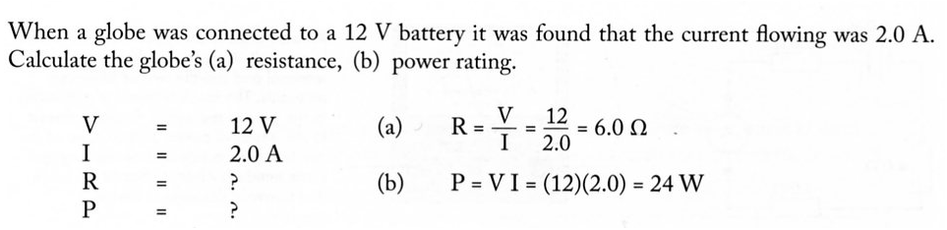

2.
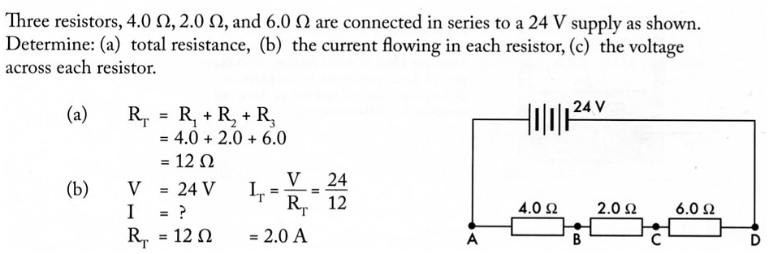
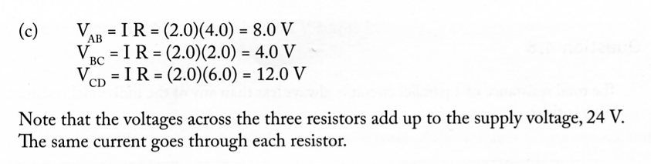

3.
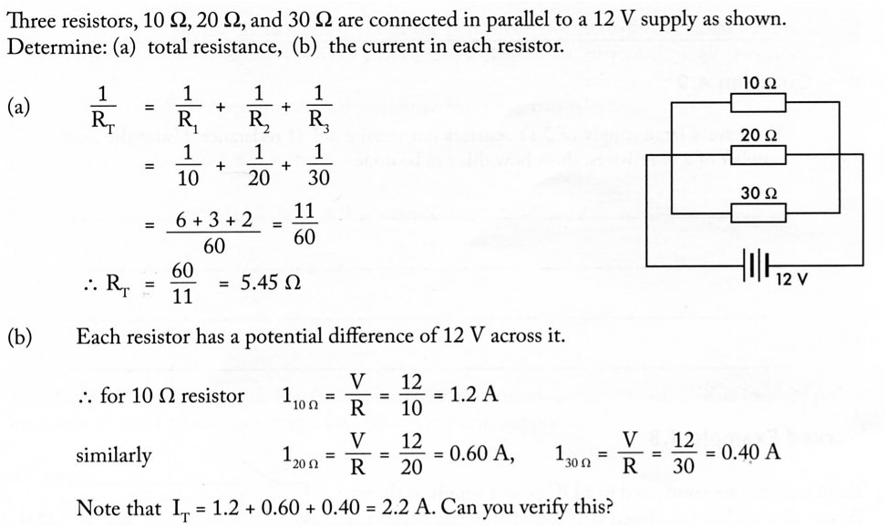

Complex Circuits

Most electrical circuits are a combination of series and parallel circuits. To determine the equivalent resistance of the circuit, each part of the circuit is dealt with separately and simplified to a series circuit. The diagram below shows how a network of resistors can be simplified to a single equivalent resistor.
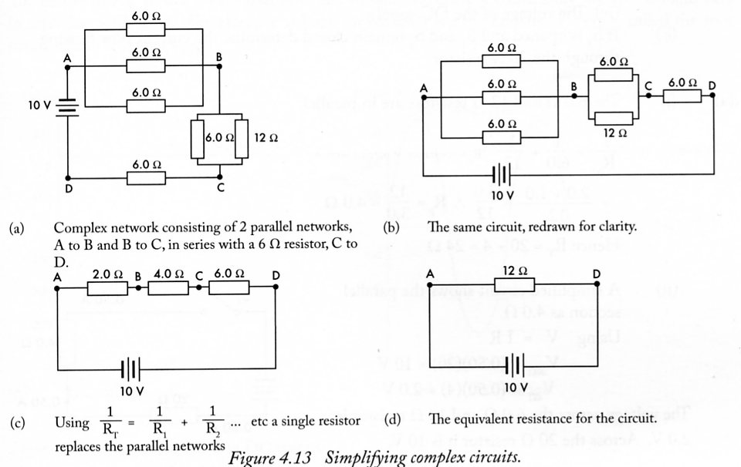

Examples
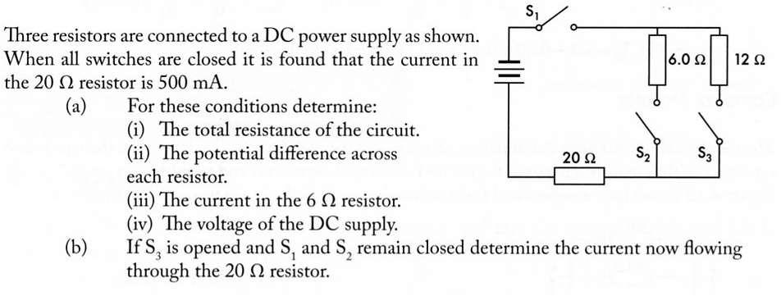
1.

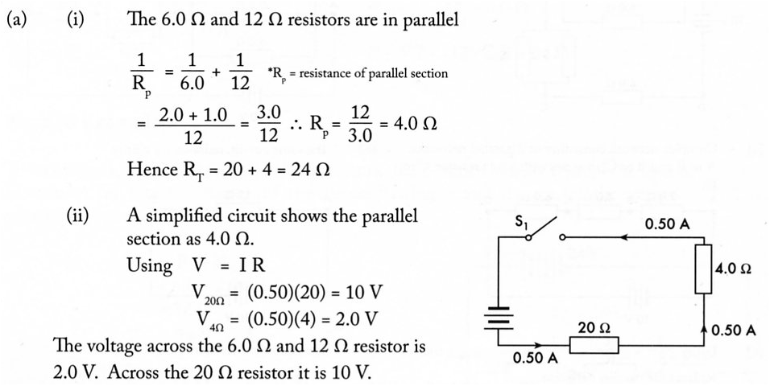
2.

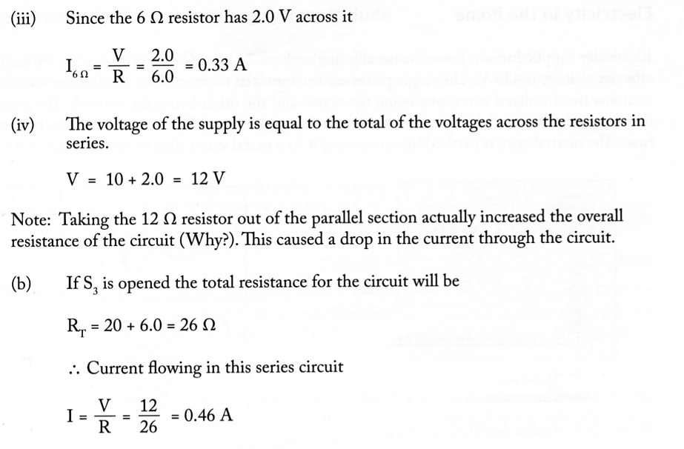

3.
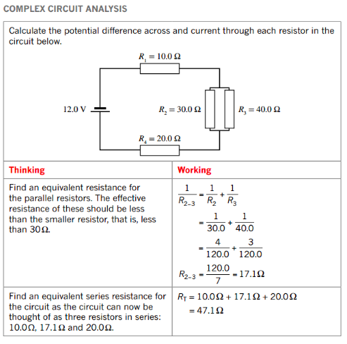
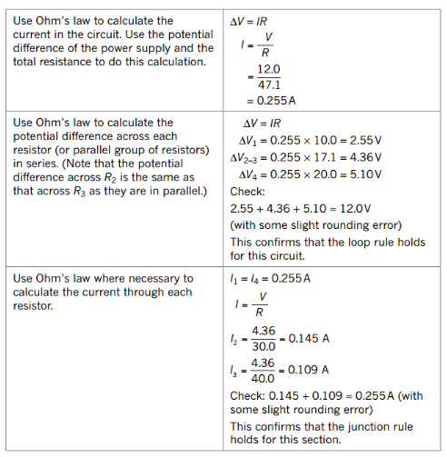

AC POWER SUPPLY

The power generated for both homes and industry is alternating current (AC). This form of power
has many distinct advantages over a DC (direct current) supply.

AC power

• More easily generated.
• Generally safer and cheaper for most applications.
• Easily transformed to higher or applications lower voltages is suitable for devices such as
clocks and tape recorders since its frequency can be precisely controlled.
• Can be transmitted at high voltages to minimise energy losses.

The nature of AC power means that both the voltage and current continually rise and fall and vary in direction with time. The effective voltage (or current) is a mathematical average called the root mean square voltage (V_{RMS}).
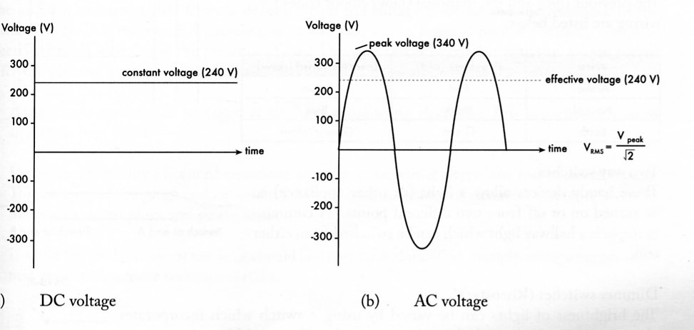

ELECTRICAL SAFETY

Effects Of Current On Humans

When an electric shock occurs, it depends on the resistance of the part of the body affected.

e.g. Outer skin has a high resistance (poor conductor) while internal tissues underneath have
a much lower resistance (better conductor).

Wet or sweaty skin has a much lower resistance again, resulting in even better
conduction.

Muscles are the most sensitive to electric currents, given that the electrical impulses sent by nerves from the brain control their movement. Any outside currents can over-ride these electrical impulses and cause the muscle to contract into spasm.

i.e. The heart can go into ventricular fibrillation (or even stop) during electrocution where it
ceases to beat rhythmically.

The effects on the human body are summarised below.
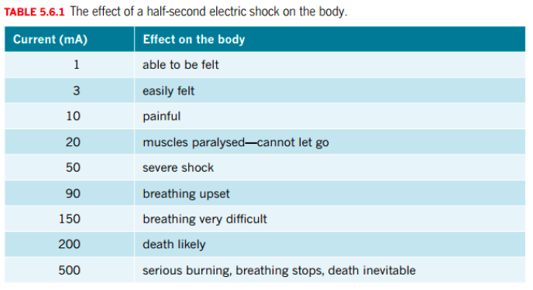

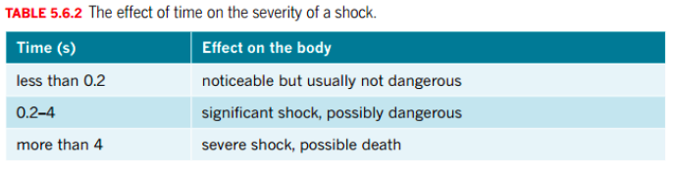

When the heart has stopped or is in ventricular fibrillation, it is externally started again by using “paddles” to send a large current through it. This causes the heart to “kick start” and/or resume its normal rhythm.

Household Wiring

All appliances and switches are arranged in parallel to allow them to be turned on and off independently.
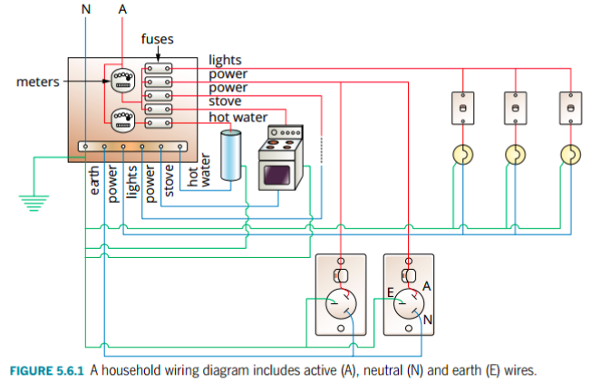

The active wire that brings energy into the household passes through the meter and is then directed through the fuses for the power and light circuits.

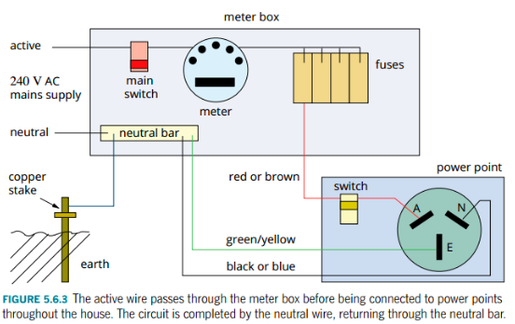

Safety Devices

1. Fuses

These are designed to melt when a current that is above the desired maximum (e.g. 10 A)
flows in a household circuit.

This could occur if a power board (or single socket with double adaptors “piggy-backed”) is
overloaded with too many devices. The more devices placed in parallel, the lower the
resistance and higher the current drawn from the board. If this total current exceeds 10 A,
then the wiring could heat up and melt, causing a fire. The fuse wire melts first and protects
any wiring.
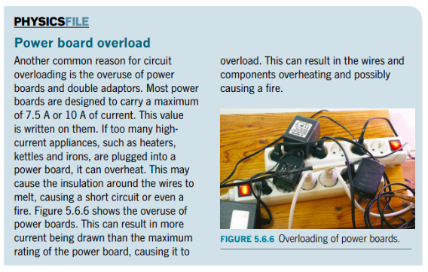

2. Circuit Breakers

These detect if the current has exceeded the maximum and switch off to protect the wiring.
They can easily be reset. They are equivalent to fuses in their performance.

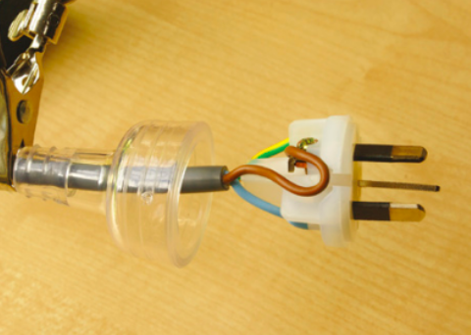
3. Earth Wire

Three pin plugs have an earth wire that is connected externally from the house to a water pipe by a wire. All devices within the house have a wire leading to this connection with the earth.

Should the casing of a device become “live” due to a short- circuit, the earth wire acts as a short-circuit to the ground, causing a large current to flow to earth and tripping the
appropriate fuse or circuit breaker.

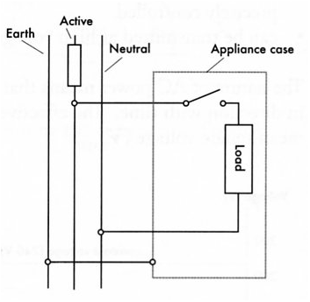
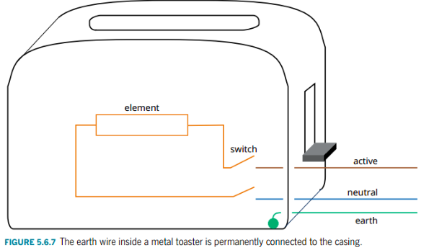

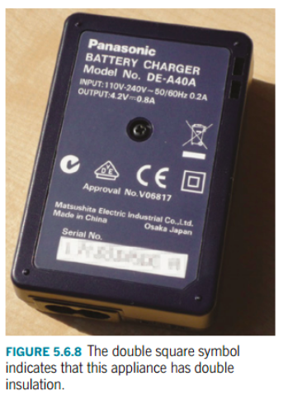
4. Double Insulation

Appliances with double insulation are made largely of plastic and the active and neutral wires are double- wrapped in plastic. The plugs on these devices have only two pins - there is no need for an earth wire.

Double insulation is not a foolproof method of preventing shocks. Nevertheless it is better protection than an earth wire.

5. Earth Leakage Circuit Breakers (ELCB)

Also known as residual current circuit breakers (RCCB), these devices monitor the current in both the active and
neutral wires (which should be the same).

If the current in one drops slightly due to a “leakage” of current (as in a short circuit), it disconnects the circuit in less than 30 ms. This is 6-8 times faster than a fuse and is far safer, resulting in the person not even detecting the current in many cases and hence avoiding a shock.

It has been a law in WA for many years for new homes to have ELCB’s in their meter boxes.

6. Double Pole Switches

These connect (and disconnect) both the active and neutral
wires when the switches / switch is operated . This is
preferable to the action of the single pole switches (DPST)
which could, through incorrect wiring, leave an appliance effectively connected
to the mains even though the switch is off.

Plugs

There are two types.

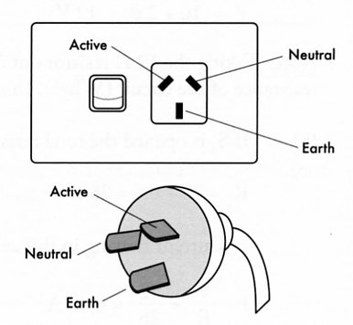
1. Three Pin

This has three wires connected to it.

Active - carries the current to the appliance (brown in
colour).

Neutral - return wire to the switchboard or meter box
(blue).

Earth Wire - provides a connection to earth in case
of short circuits (green and yellow).

2. Two Pin

This has only the active and neutral wires. No earth wire is required as these are only used for
double-insulated appliances.

